A
MAJOR PROJECT REPORT ON
COLLEGE WEBSITE
A REPORT SUBMMITED IN PARTISLFULFILMENT OF THE REQUIRMENT FOR THE AWARD OF THE DEGREE
OF
THE DIPLOMA PROGRAM IN
COMPUTER SCIENCE & ENGINEERING


(Session 2023-2024)

SUBMMITED TO: SUBMITTED BY:
Pratistha Sharma Bhawani Shankar Kumawat(CS2017L001/180) (Lecturer Computer Science Bilal Hussain (CS/2016001/180)
& Engineering) Bhawani Shankar Saini (CS2017L002/180)

DEPARTMENT OF COMPUTER SCIENCE & ENGINEERING GOVERNMENT RAM CHANDRA KHAITAN POLYTECHNIC COLLEGE
JAIPUR

BOARD OF TECHNICAL EDUCATION,JODHPUR

CANDIDATE’S DECLRATION
I certify that work, which is being presented in the project entitled “COLLEGE WEBSITE” Submitted By Bhawani Shankar Kumawat , Billal Hussain , Bhawani Shankar Saini students of final year diploma in computer science &engineering in partial fulfillment for award of degree of diploma is a record of my own work carried out by us under guidance and supervision of ms. Pratistha Sharma
This work has not submitted elsewhere for award of any other degree.

Date: Name & Signature of student
Place:

CERTIFICATE
This is to certify that this report embodies the original work done by Bhwani Shankar Saini,Bhawani Shankar kumawat and Bilal Hussain during the project training as a partial fulfillment of the requirement for the award of the diploma in Computer Science &Engineering, of the Board of Technical Education Rajasthan.

Mr. Sunil Sharma
HOD (Computer Science)

ACKNOWLEDGEMENTS
We express my sincere gratitude and indebtedness to the project guide Ms. Pratistha Sharma for her valuable, encouragement and affection for the successful completion of this work. His sincere sympathy and attitude always encouraged me to carry out the present work firmly. I express my thankfulness to Mr. Sunil Sharma Head of the Department of Computer Science & Engineering, of Government Ram Chandra Khaitan Polytechnic College ,Jaipur for providing us with best facilities in the Department and his timely suggestions. Last but not least I would like to thank all my friends and well wishers who were involved directly in successful completion of the present work.

Bhawani Shankar Kumawat (CS2020L001/180)
Bilal Hussain (CS20206001/180) Bhawani Shankar Saini (CS2020L002/180)

PREFACE
This report consists of the work done during the summer training at Government Ram Chandra Khaitan Polytechnic College ,Jaipur under the supervision of Ms.Pratistha Sharma(Lecturer, CSE). The report first shall give an overview of the tasks completed during the period f training. Report shall also elaborate on the future works which can be persuaded as an advancement of the current work. I have tried my best to be persuaded as an advancement of the current work. I have tried my best to keep report simple yet technically correct. I hope I succeed in my attempt.

Bhawani Shankar Kumawat (CS2020L001/180)
Bilal Hussain (CS2020001/180) Bhawani Shankar Saini (CS2020L002/180)

Index
- Introduction 7
- Project Title
- Purpose
- Scope
- Abbreviation
- Technologies

- Detailed life cycle of project 21

  - Requirement Analysis
  - System Analysis and design
  - Testing

- Details of hardware & software used 25

  - Hardware Specification
  - Software Specification

- Data base model 26

  - Tables used

- Web pages 30
- Conclusion 40
- References 41

INTRODUCTION
In today's technical world technology is overcoming each and every activity in our daily life. Everything is getting online whether billing, getting information, giving exams, online shopping, Admissions etc.
College website is integral web application that handles various academic and nonacademic activities of a college.
The college website can be a very valuable source of information. Sometimes looking at the information for current students is more informative than what is included under the prospective student section.
So being a computer science student of our college we thought of providing a COLLEGE WEBSITE
Project Title: COLLEGE WEBSITE

Purpose

The main purpose to develop web application for Govt. Polytechnic College Tonk that will provide accessible information needed by the student and users. This website is also useful for College faculty.
This website provides useful contents to update the needed information about the college, courses, Student Placement, announcement etc.

Scope:

The main objective to develop this website is to provide useful update the needed information about the college.

Abbreviation:

S.N. | Acronym | Explanation
1. | HTML | Hyper Text Markup Language
2. | CSS | Cascading Style Sheet

Technologies:
Modern websites are built using a myriad of technologies. While you don’t have to be an expert in these systems to manage your website project properly, it is a good idea to familiarize yourself with the basics of the available technologies and their pros and cons in order to understand the long-term impact they will have on your website. There is no single “right technology” for building websites. Many factors should be a part of your decision, such as your vendor’s experience, vendor’s collective team talents, development and licensing costs, as well as your organization’s internal guidelines, website performance, maintainability, ease of scalability for growth and more.

HTML

HTML is the standard markup language for creating Web pages.
- HTML stands for Hyper Text Markup Language
- HTML describes the structure of Web pages using markup
- HTML elements are the building blocks of HTML pages
- HTML elements are represented by tags HTML tags label pieces of content such as "heading", "paragraph", "table", and so Browsers do not display the HTML tags, but use them to render the content of the page

Hypertext Markup Language (HTML) is an authoring tool that is used in creating Internet Web pages. When using HTML a block of text is surrounded with tags that indicate to an Internet browser how the text is to appear (for example, in bold face or italics). HTML is a collection of platform-independent styles (indicated by markup tags) that define the various components of a Web document. It is the preferred tool for creating Web pages because it is understood by all Internet browsers. Many Web designers who use HTML find it simple to learn and easy to use, because it offers a stripped-down approach to Web design that does not rely a lot on extraneous features. Another aspect of its popularity is its ability to deal quickly with bandwidth-friendly text documents.
Internet lingo is full of acronyms and buzzwords. When you consider what each letter in HTML stands for, it may be easier to understand exactly what it does and how it works.
As Joe Burns stated on www.htmlgoodies.com:

"Hyper is the opposite of linear. It used to be that computer programs had to move in a linear fashion. This before this, this before this, and so on. HTML does not hold to that pattern and allows the person viewing the World Wide Web page to go anywhere, any time they want.
"Text is what you will use. Real, honest to goodness English letters.

"Mark up is what you will do. You will write in plain English and then mark up what you wrote. More to come on that in the next Primer.
"Language because they needed something that started with "L" to finish HTML and Hypertext Markup Louie didn't flow correctly. Because it's a language, really—but the language is plain English.
THE HISTORY OF HTML

HTML, along with Hypertext Transport Protocol (HTTP) and uniform resource locator (URL), were created by Tim Berners-Lee in the latter part of the 1980s. Berners-Lee was collaborating in Switzerland at the CERN physics laboratory with

another scientist by the name of Robert Calliau. When Berners-Lee was faced with the problem of organizing his notes, he created HTML to make the information accessible and easy to link.
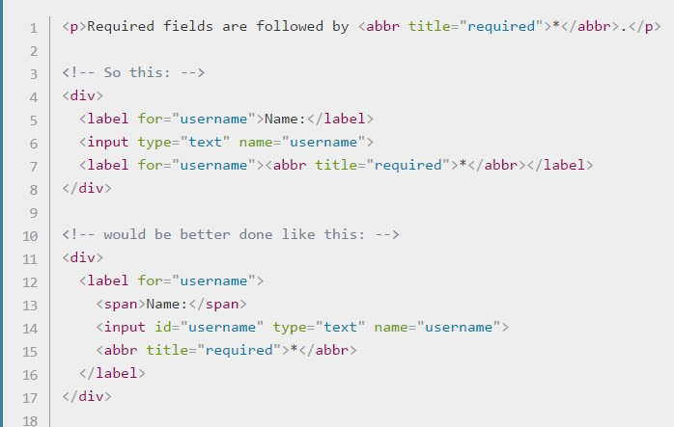

CSS (Cascading Style Sheet)
- CSS stands for Cascading Style Sheets
- CSS describes how HTML elements are to be displayed on screen, paper, or in other media
- CSS saves a lot of work. It can control the layout of multiple web pages all at once
- External stylesheets are stored in CSS files
CSS (Cascading Style Sheets) is used to style and layout web pages — for example, to alter the font, colour, size and spacing of your content, split it into multiple columns, or add animations and other decorative features. This module gets you started on the path to CSS mastery with the basics of how it works, including selectors and properties, writing CSS rules, applying CSS to HTML, how to specify length, colour, and other units in CSS, cascade and inheritance, and debugging CSS.

How does CSS affect HTML?

Web browsers apply CSS rules to a document to affect how they are displayed. A CSS rule is formed from:
- A set of properties, which have values set to update how the HTML content is displayed, for example, I want my element's width to be 50% of its parent element, and its background to be red.
- A selector, which selects the element(s) you want to apply the updated property values to. For example, I want to apply my CSS rule to all the paragraphs in my HTML document.
A set of CSS rules contained within a stylesheet determines how a webpage should look. You will learn a lot more about what CSS syntax looks like in the next article of the module — CSS Syntax.

At its most basic level, CSS consists of two building blocks:

- Properties: Human-readable identifiers that indicate which stylistic features (e.g. font, width, background color) you want to change.
- Values: Each specified property is given a value, which indicates how you want to change those stylistic features (e.g. what you want to change the font, width or background color to.)
A property paired with a value is called a CSS declaration. CSS declarations are put within CSS Declaration Blocks. And finally, CSS declaration blocks are paired with selectors to produce CSS Rulesets (or CSS Rules).

- Remember the data on the client-side (“local storage”).
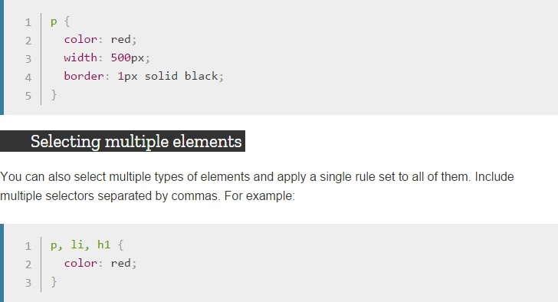

Visual Studio

The Visual Studio integrated development environment is a creative launching pad that you can use to edit, debug, and build code, and then publish an app. An integrated development environment (IDE) is a feature-rich program that can be used for many aspects of software development. Over and above the standard editor and debugger that most IDEs provide, Visual Studio includes compilers, code completion tools, graphical designers, and many more features to ease the software development process.

Popular productivity features

Some of the popular features in Visual Studio that help you to be more productive as you develop software include:
- Squiggles and Quick Actions
Squiggles are wavy underlines that alert you to errors or potential problems in your code as you type. These visual clues enable you to fix problems immediately without waiting for the error to be discovered during build or when you run the program. If you hover over a squiggle, you see additional information about the error. A light bulb may also appear in the left margin with actions, known as Quick Actions, to fix the error.
- Code Cleanup
With the click of a button, format your code and apply any code fixes suggested by your code style settings, .editorconfig conventions, and Roslyn

DETAILED LIFE CYCLE OF PROJECT
We have used Waterfall Model as Software Engineering life Cycle Process. It is the simplest; oldest and most widely used process model for software development
.This model acquires its name from the fact that classic software life cycle is represented as a sequence of descending steps.
sequence of descending steps.

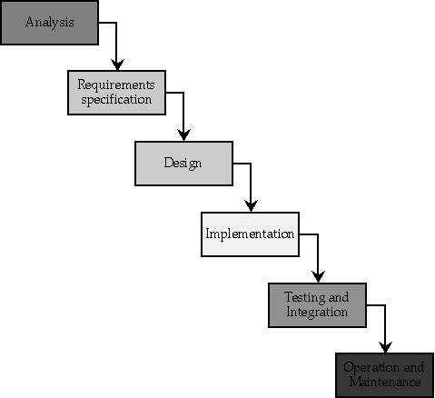

Requirement Analysis:
This process is also known as feasibility study. In this phase, the development team studied the site requirement. They investigate the need for possible dynamic representation of the site and increase security features. By the end of feasibility study, the team furnishes a document that holds the different specific recommendations for the candidate system. It also includes personnel assignments, costs, project schedules, target dates etc. the requirement gathering process is

intensified and focused specially on software. The essential purpose of this phase is to find the need and to define the problem that needs to be solved. During this phase following facts were gathered.
- Determined the user need
- Identified the facts
- Establish the goals and objective for the proposed system
- Feasibility for the new system

System Analysis and Design:
In this phase the software’s overall structure and its nuances are defined. In terms of client server technology the no of tiers needed for the package architecture, database design, data structure design etc are defined in this phase. Analysis and Design are very crucial in entire development cycle. Any glitch in this phase could be expensive to solve in the later stage of software development. Hence following is the essential approach taken during website designing:
- DFD
- Database Designing
- Form Designing
- Pseudo code for methods
Testing:
Once the code is generated, the website testing begins. Different testing methodologies are done to unravel the bugs that were committed during the previous phases. Different testing methodologies are used:
- Acceptance testing
- White Box Testing
- Black Box Testing

Methodology used for testing
The completion of a system will be achieved only after it has been thoroughly tested. Though this gives a feel the project is completed, there cannot be any

project without going through this stage. Hence in this stage it is decided whether the project can undergo the real time environment execution without any break downs, therefore a package can be rejected even at this stage.
Testing methods

Software testing methods are traditionally divided into black box testing and white box testing. These two approaches are used to describe the point of view that a test engineer takes when designing test cases.
- Black box testing - Black box testing treats the software as a "black box," without any knowledge of internal implementation. Black box testing methods include: equivalence partitioning, boundary value analysis, all- pairs testing, fuzz testing, model-based testing, traceability matrix, exploratory testing and specification-based testing.
- White box testing - White box testing, by contrast to black box testing, is when the tester has access to the internal data structures and algorithms (and the code that implement these).White box testing methods can also be used to evaluate the completeness of a test suite that was created with black box testing methods. This allows the software team to examine parts of a system that are rarely tested and ensures that the most important function points have been tested.
- Grey Box Testing - Grey box testing involves having access to internal data structures and algorithms for purposes of designing the test cases, but testing at the user, or black-box level. Manipulating input data and formatting output do not qualify as "grey box," because the input and output are clearly outside of the "black-box" that we are calling the system under test. This distinction is particularly important when conducting integration testing between two modules of code written by two different developers, where only the interfaces are exposed for test. Grey box testing may also include reverse engineering to determine, for instance, boundary values or error messages.

- Acceptance testing - Acceptance testing can mean one of two things:

  - A smoke test is used as an acceptance test prior to introducing a build to the main testing process.
  - Acceptance testing performed by the customer is known as user acceptance testing (UAT).
- Regression Testing - Regression testing is any type of software testing that seeks to uncover software regressions. Such regression occurs whenever software functionality that was previously working correctly stops working as intended. Typically regressions occur as an unintended consequence of program changes. Common methods of regression testing include re-running previously run tests and checking whether previously fixed faults have re- emerged.
- Non Functional Software Testing - Special methods exist to test non- functional aspects of software.
- Performance testing checks to see if the software can handle large quantities of data or users. This is generally referred to as software scalability. This activity of Non Functional Software Testing is often times referred to as Load Testing.
- Stability testing checks to see if the software can continuously function well in or above an acceptable period. This activity of Non Functional Software Testing is often times referred to as indurations test.
- Usability testing is needed to check if the user interface is easy to use and understand.

DETAILS OF HARDWARE & SOFTWARE

Hardware Specification:
Disc Space : 2 GB
Processor : Intel
Memory : 2 GB RAM
File System : 32 Bit/64 Bit

Software Specification:
Operating System (Server Side) : Windows Operating System (Client Side) : Windows
Front-End Language : HTML, CSS,
Server side Language : ASP.Net
Database :
Web Browser : Chrome, Firefox any browser

Web Pages

Home Page

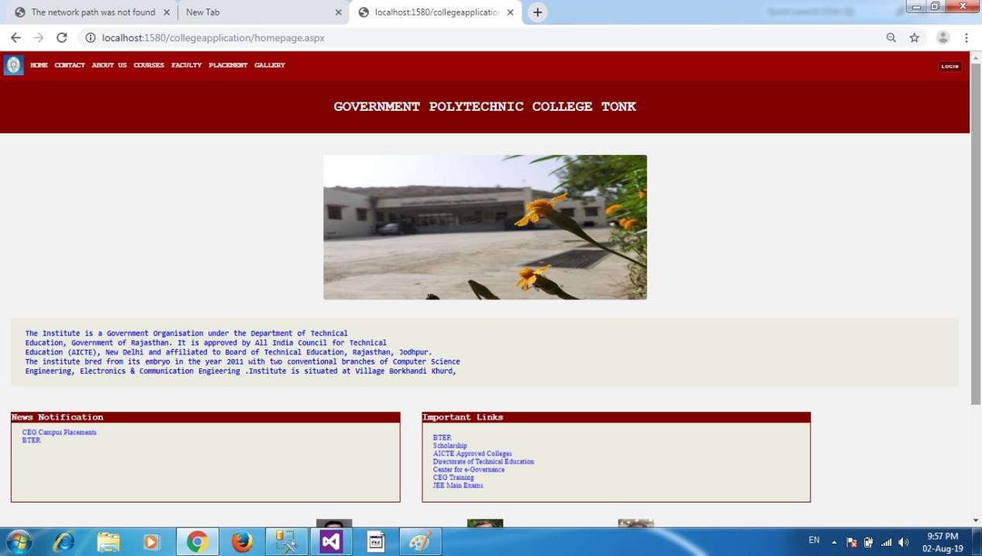

Contact

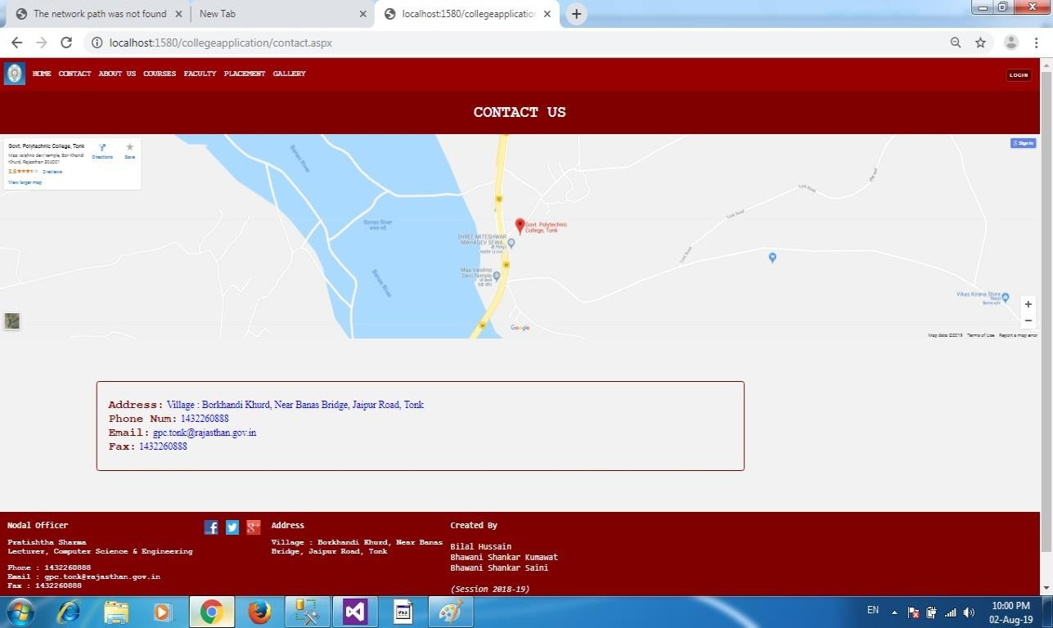

About Us

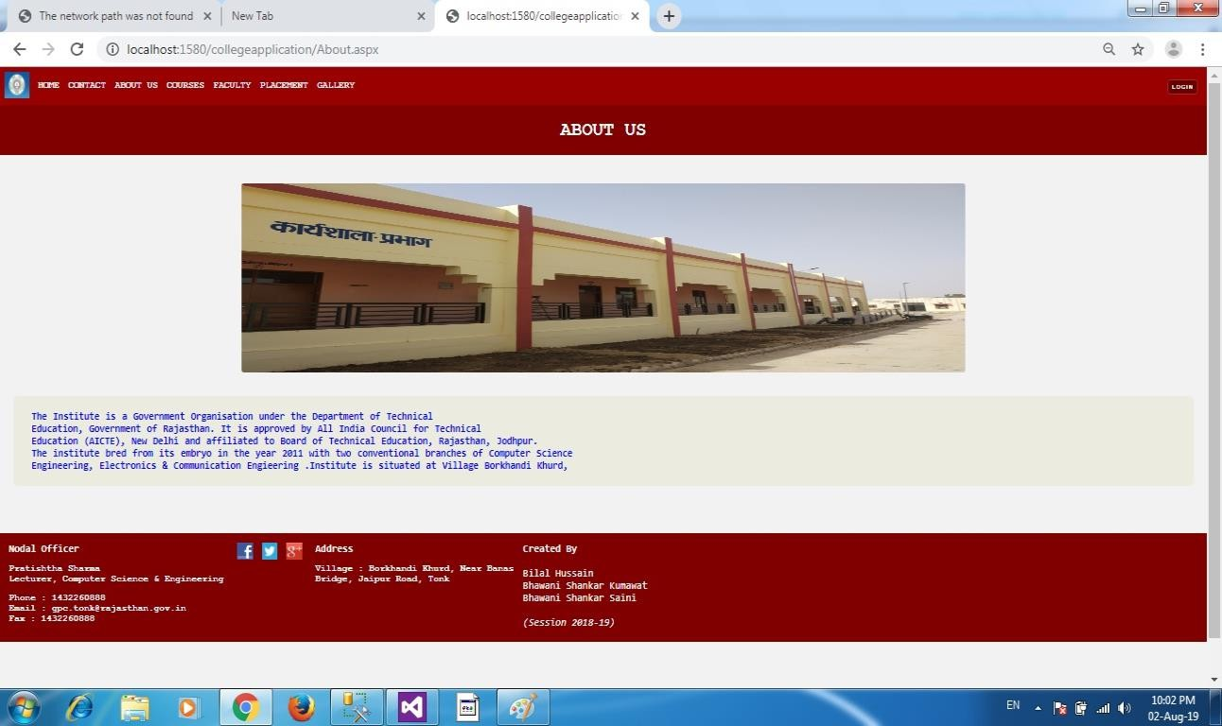

Courses

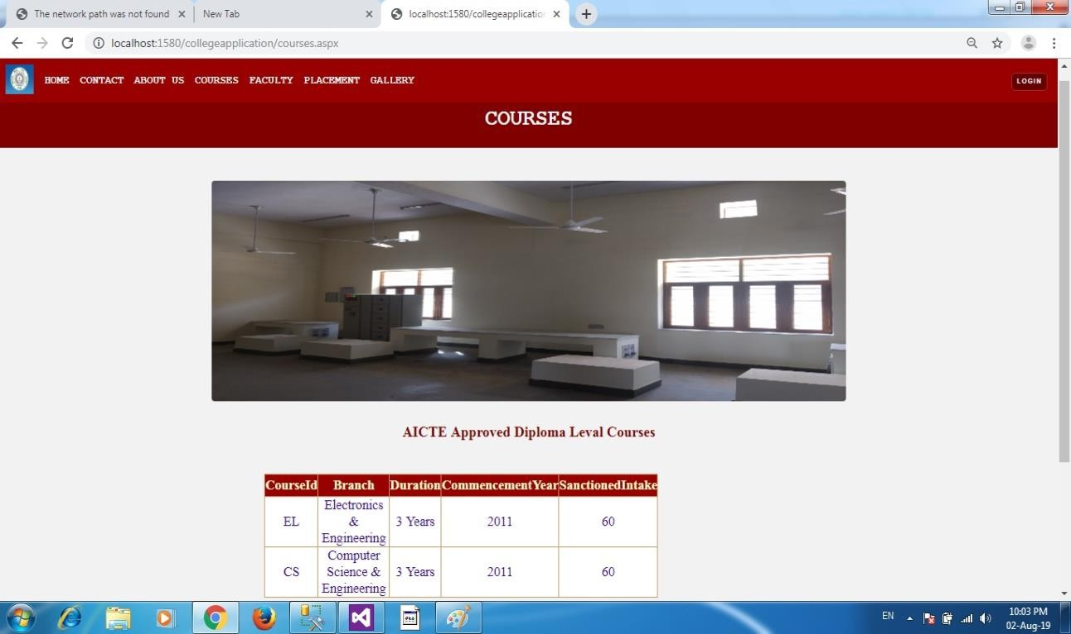

Faculty

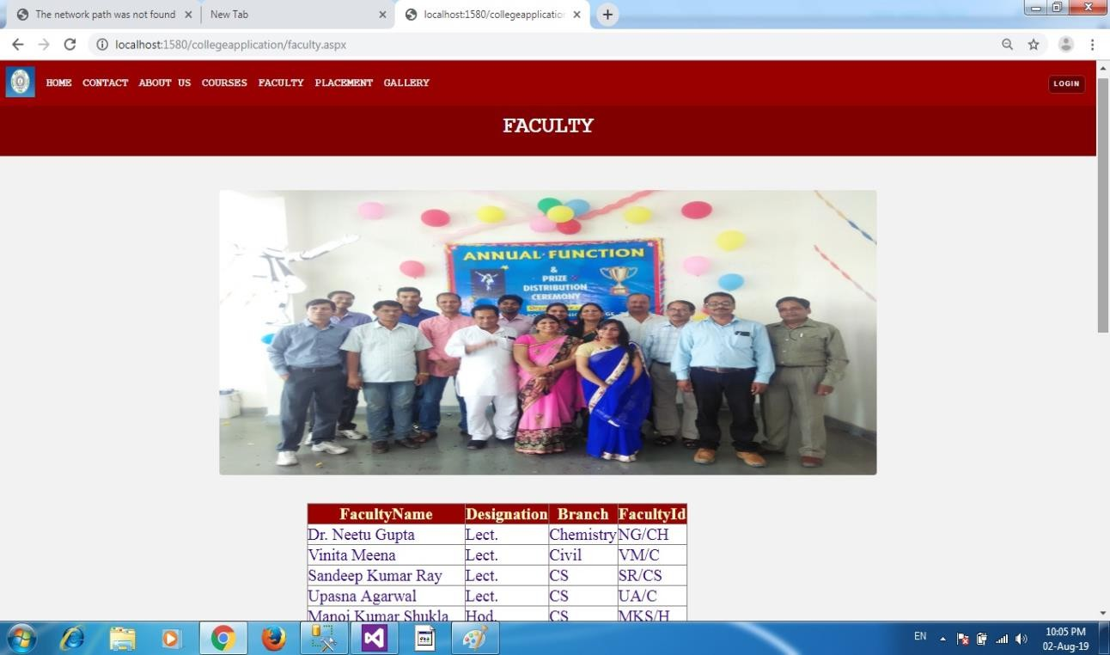

Placement

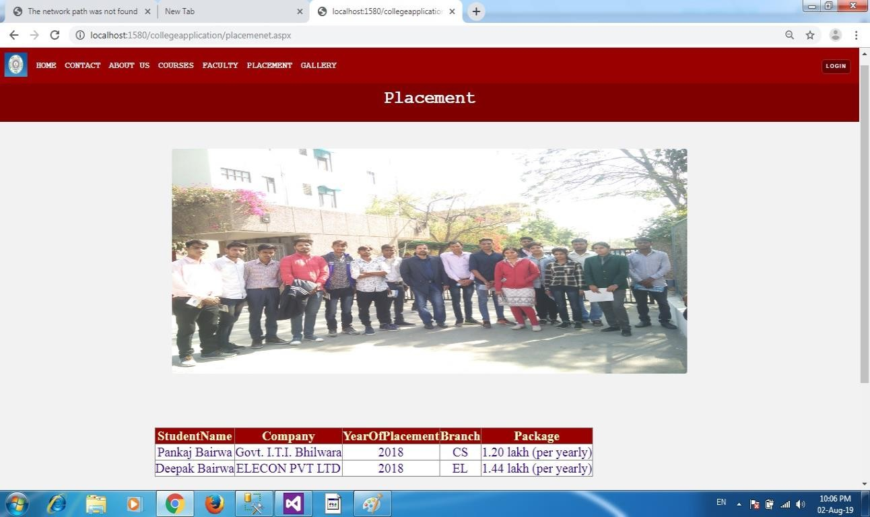

Gallery

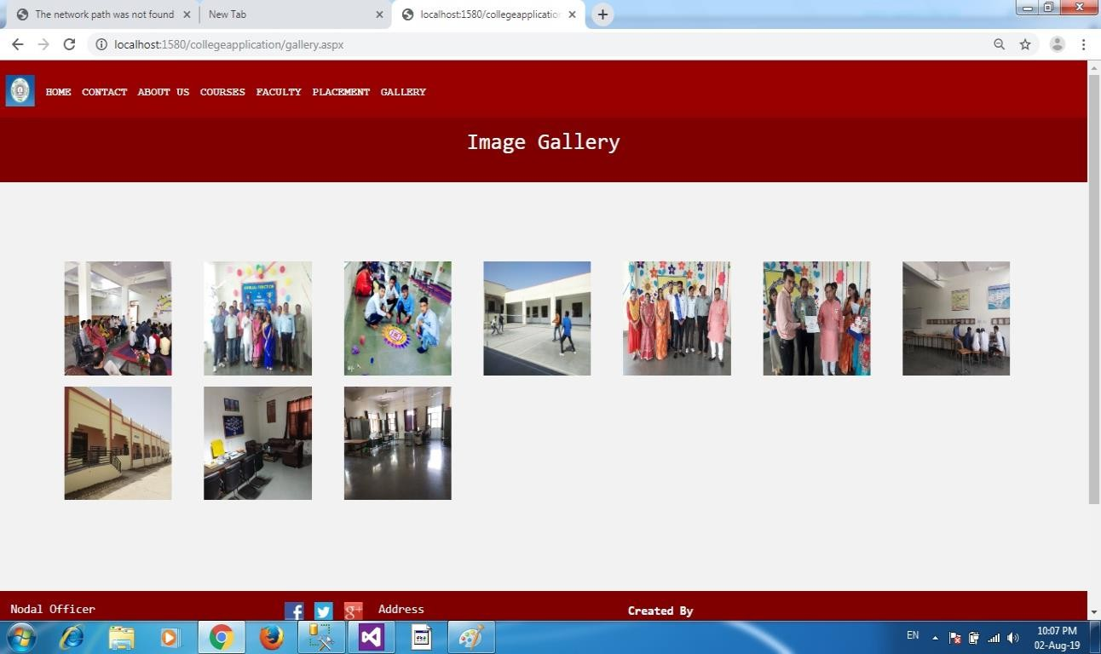

Login

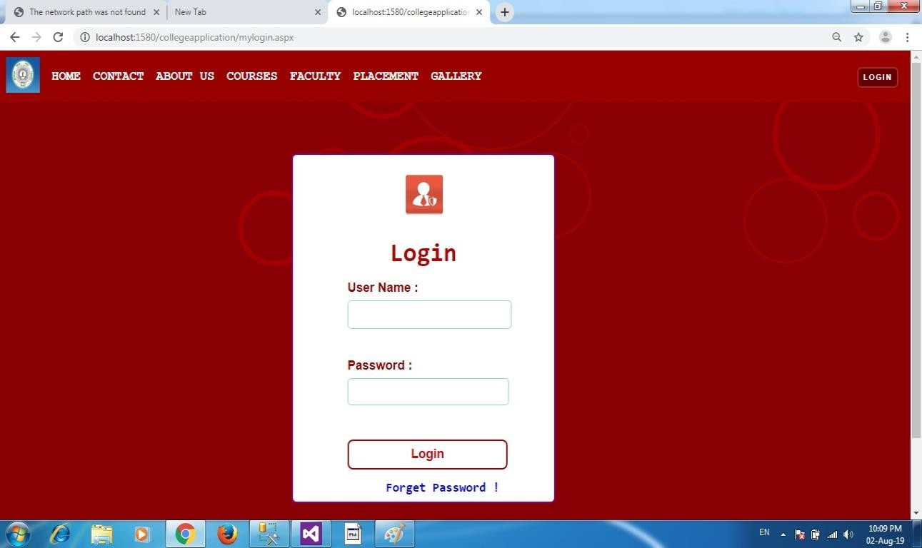

Admin Panel

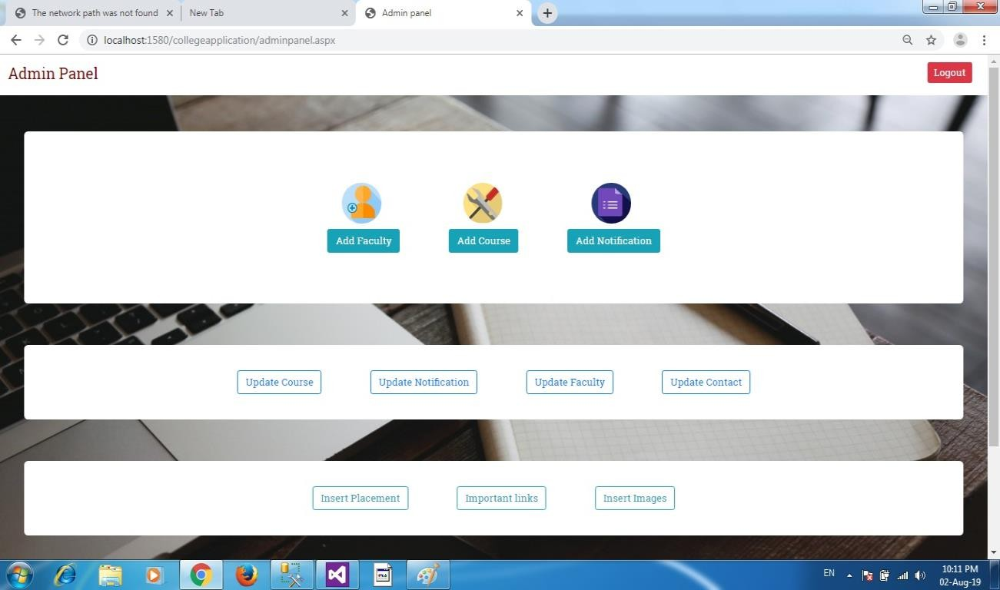

CONCLUSION
The project report entitled "COLLEGE WEBSITE CREATION" has come to its final stage. The Web application has been developed with much care that it is free of errors and at the same time it is efficient and less time consuming. The important thing is that the Website is robust. We have tried our level best to make the site as dynamic as possible. Also provision is provided for future developments in the Website. The entire Website is secured.

FUTURE SCOPE

REFRENCES

Books

- Beginning Asp.Net 3.5 in C# 2008(By: Matthew MacDonald)

- Professional .Net Framework 3.0(By: Joe Duffy (Wrox))

Web Links

- www.eggheadcafe.com

- www.w3schools.com

- www.javatpoint.com

